Exercise 2-5 The table challenge

Complete the following tasks in table_template.html. When you finished all the four tables and send the file to me.

### Exercise 2-5(1): Making a simple table

Open table_template.html and add the following table to the table.(Note that I’ve add a 1-pixel border around cells with a style rule just to make the structure clear.)

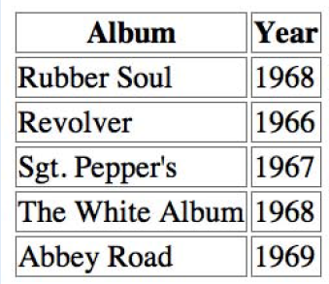

### Exercise 2-5(2): Column spans

Try writing the markup for the following table

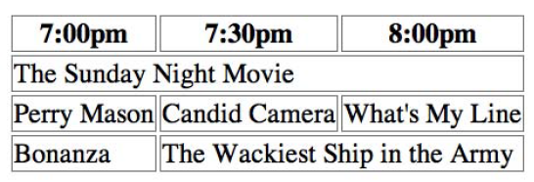

### Exercise 2-5(3): Row spans

Try writing the markup for the following table

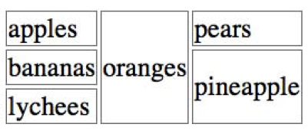

### 2.5 Exercise(4) : The table challenge

Now it’s time to put together the table writing skills you’ve acquired in this chapter. Your challenge is to write out the source document for the following table

